Lecture 18: Chapter 9: Evaluating Algorithms – Mon Oct 27 or Tues Oct 28
Announcements

Reading:
- Chapter 9 Brouillette and Chapter 22 (Liang)

Assignments:
- Assignment #7 – due on Oct 29 (MW class) or Oct 30 (TR class) (no late assignments accepted)

Today’s Goals
- Analysis of Algorithms
- Measuring Time Efficiency Using Big-O Notation
- Comparison of Big-O Functions
- Big-O Estimation and Polynomial Functions

Today’s Terminology

Terminology
- Algorithm Analysis
  - Topic in computer science where you examine the efficiency of algorithms
  - Topic of an entire course – CS 4720 Design and Analysis of Algorithms
  - In CS1450 we only do a small introduction

- Asymptotic Complexity
  - The order, or dominant term, of a growth function
  - General nature of function as n increases

- Growth Function
  - Function that shows complexity of an algorithm relative to the size of the problem (n).
  - Can represent time complexity or space complexity.

- Big-O Notation
  - Notation to represent the order, or asymptotic complexity, of an algorithm.
  - Denoted with a “Big O” - O

- Order of n
  - Same as O(n)

Analysis of Algorithms

Algorithm Design
- Developing solutions to solve programming problems
- Possible to create many different algorithms to solve a problem
- We’ve seen that there are several sorting and searching algorithms

Algorithm Analysis
- Predict the efficiency of algorithms
- Efficiency covers lots of resources
  - CPU (time) usage
  - Memory usage
  - Disk usage
  - Network usage
- Will be looking only at CPU usage – time complexity – as size of input increases
- Common algorithmic techniques for developing efficient algorithms
  - Dynamic programming
  - Divide-and-conquer Study these in-depth in CS4720
  - Backtracking

Purpose
- Possible to have several algorithms that are a solution to a problem
- Need to compare the efficiency of algorithms to select the best algorithm
- Understanding algorithm efficiency is also important when building data structures
  - Data structure built correctly
    - Efficient use of both CPU and memory
    - Can be reused in many different applications
  - Data structure built incorrectly
    - Problematic in terms of CPU and memory
    - Not reusable
- Interviewers like to ask about Big-O!

Measuring Time Efficiency Big-O Notation

What is Algorithms Efficiency?
- Assume you have program that needs to search a list
- We’ve learned about linear search and binary search
- Questions:
  - How do we determine which one to select?
  - We could examine efficiency as use of the CPU, memory, or other resources
  - What if we decided to compare the two approaches based on execution times?
- Issues:
  - Computer processing can change results
    - Concurrent processing
    - System load
  - Input can change results
    - Linear search is faster if item we are searching for is the 1st item
- Need:
  - Ability to compare different algorithms independent of above issues
  - Need a machine and language independent measurement

Big-O Notation
- A theoretical approach for analyzing algorithms independent of computers and specific input.
- Estimates algorithm time complexity
  - Classifies the upper-bound (worst case) time behavior of an algorithm
  - Estimates change in execution time based on input size
  - Gives us a growth rate – use to compare algorithms

How fast an algorithm’s execution time increases as the input size increases

- Notation: O(n)
- Read: order of n Looks at this relationship

Best, Worst and Average Cases
- An algorithm’s execution time can vary depending on the input
- Can analyze 3 cases:
  - Best-case input
    - Input that results in shortest execution time
    - Of little interest because it does not represent typical behavior
  - Average-case input
    - Average amount of time among all possible inputs of the same size
    - Often represents typical behavior
    - In most cases difficult to compute
  - Worst-case input
    - Input that results in the longest execution time
    - Easier to perform than average
    - Useful because we know algorithm won’t be slower than this!
    - Analysis is generally conducted for worse case

Example – Linear Search
- Not very efficient algorithm
- Compares key with array elements sequentially until key is found or no more elements to compare

- Different input cases
  - Best case: 1 comparison 1st element is key
  - Worst case: n comparisons last element is key or doesn't find key
  - Average: n/2 comparisons 50% of elements are examined before key is found

- Examples
  - n = 10 worse case is 10
  - n = 100 worse case is 100
  - n = 1000 worse case is 1000

  - Double array size, double comparisons
  - Execution time grows linearly as the array size grows
  - Big-O for linear search -> O(n)

Comparison of Big-O Functions

Growth Rates
- Easy way to think of Big-O
  - A rating system for algorithms.
  - The rating (Big-O) tells you how fast you can expect the algorithm to be as the number of inputs gets larger and larger.
  - Now you can compare algorithms based on their ratings like we do so many things in life!

- The ratings from best to worse are
  - Constant O(1)
  - Logarithmic O(log n)
  - Linear O(n)
  - Log Linear O(n log n)
  - Quadratic O(n²)
  - Polynomial O(n^{c})
  - Exponential O(2^{n})

- Helpful website
  - http://www.bigocheatsheet.com/
  - This site contains the following helpful chart.
  - As n increases, the various growth functions diverge dramatically.

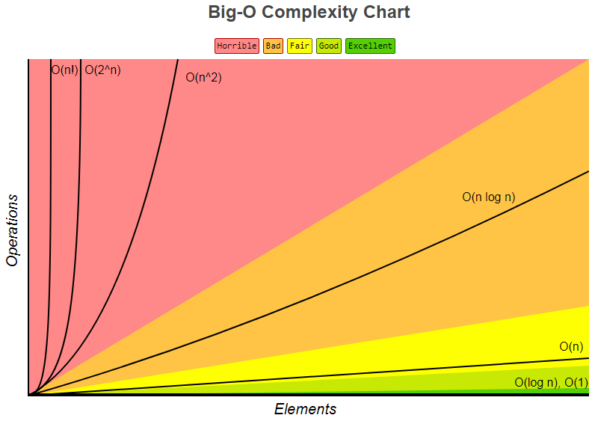

Graphs for Growth Rates
- Understanding the graphs for each growth rate is the important part.

- Constant
  - O(1)
  - Time does not change as the number of inputs increases
  - If 1 input takes 1 seconds then so does 10, 100, 1000 or 1 million inputs
  - Example:
    - Retrieval algorithms for queues
    - Peek, element, size

Returns 1st element Updated as values are added and removed
so list size makes It’s a simple operation that list size doesn’t affect
no difference!

- Logarithmic
  - O(log₂ n)
  - Nothing beats constant, but logarithmic is close!
  - The curve has a steep initial rise but then becomes almost flat.
  - Algorithm or data structure that repeatedly divides input set by 2 is probably O(log₂ n)
  - Time grows by one unit each time the number of inputs doubles
  - If 10 inputs take 3.3 second, 100 take 6.6, 1000 take 9.9 second, 1,000,000 take 19.9, etc.
  - Growth is very slow!
  - Example:
    - Binary Search

- Linear
  - O(n)
  - Time grows in direct proportion to the number of inputs.
  - 1 input takes 1 second, 10 inputs take 10 seconds, 100 inputs take 100 second, etc.
  - Example
    - Linear search

- Log Linear
  - O(n log n)
  - Combination of logarithmic and linear
  - Normally 2 parts – 1st is the O(n), 2nd is the O(log n)
  - 1 input takes 2 seconds, 10 inputs take 12 seconds, 100 inputs take 103 seconds, etc.
  - Example
    - Merge Sort

- Quadratic
  - O(n²)
  - Starting to get slow
  - 1 input takes 1 second, 10 input takes 100 second, 100 inputs take 10,000 second
  - Example
    - Selection sort
    - Bubble Sort
    - Insertion Sort
    - Quick Sort

- Exponential
  - O(2^{n})
  - Super slow!
  - Takes twice as long for every new input. Time doubles for each new input!
  - 1 input takes 1 second, 10 inputs take 1024 seconds, 100 items take 1267650600228229401496703205376 seconds

- Chapter 9 in Brouillette book has this table (p.105)
  - Note: In algorithm analysis, for log the base is usually 2, and generally omitted.

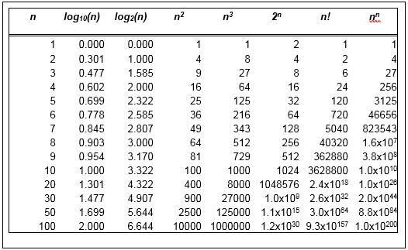

Linear search with Binary search with
100 elements 100 elements is
Is O(n) O(log n)

- Linear vs Binary Search
  - Assume the array contains 100 elements
  - Binary Search is efficient algorithm - array shrinks by 50% after each comparison
    - After 1st comparison - reduced search to 1/2 of the elements (50)
    - After 2nd comparison - reduced search to 1/2 of that 1st half (25)
    - After 3rd comparison – 13
    - After 4th comparison - 6
    - After 5th comparison – 3
    - After 6th comparison - 1
    - On 7th comparison 1 element left to compare with key

  - Linear search is not efficient algorithm
    - Worse case: 100 comparisons

Summary of Big-O for Sorting Algorithms and Data Structures
- This is a common interview question!
- These tables are from website: http://www.bigocheatsheet.com/
- The color code is:

- These are the sorting algorithms we are examining in CS1450:

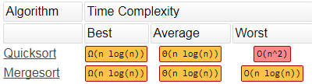

Will examine when we
discuss recursion
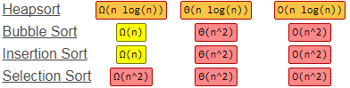

- These are the data structures we are examining in CS1450:

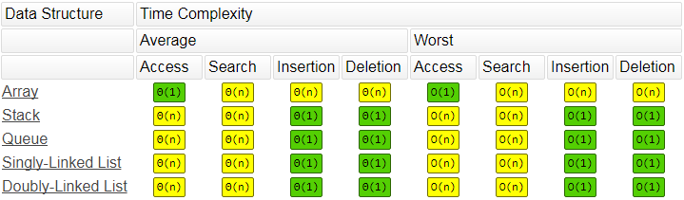

Big-O Estimation and Polynomial Functions

Asymptotic Complexity
- Based on the dominant term of a growth function
- This is the term that increases most quickly as n increases
- Gives us the general nature of the function as n increases

- To simplify finding the complexity of an algorithm
  - We are NOT interested in the EXACT number of operations!
  - We are interested in the relationship of the execution time based on number of inputs
- Since Big-O is an upper bound, we adopt two conventions:
  - Ignore leading constants
  - Ignore low order terms

Ignore Multiplicative Constants
- Example: assume an algorithm’s growth rate is estimated by this function

5n² + 20n seconds

This growth function is dominated by the n²
n² grows faster than n
Constants 5 and 20, and the secondary term n become irrelevant as n increase

Multiplicative constants become irrelevant and can be ignored

- Limitations
  - When comparing algorithms meant to run on small values of n, constants can have a large effect
  - The point is to be aware of this limitation of asymptotic complexity analysis

Ignore Non-Dominating Terms
- Example: finding the maximum number in an array of n elements
  - If array has
    - 2 elements, it takes 1 comparisons
    - 3 elements, it takes 2 comparisons
    - 4 elements, it takes 3 comparisons
  - In general, it takes n-1 comparisons

n is the dominant term -1 becomes less and less relevant as n increases, so can ignore

Example
- Assume: 3 algorithms have the following growth functions

Algorithm A: 5n³ + 2n² + 4n + 50

Algorithm B: n³ + 500

Algorithm C: n³ + 20n² + 40n + 500

- Questions: What is the Big-O complexity of each algorithm:

O(n³) because

All constant values are ignored
All coefficients of n are ignored
Only highest power of n is considered
- Main point:
  - As n becomes substantially large, the importance of these ignored elements becomes less and less significant.
  - This is sufficient to rank algorithms relative to each other.

Notes
- Big-O is a large-scale, gross estimate
- Typically look only at worse case
- Two algorithms with same Big-O are generally considered to have same efficiency. This DOES NOT mean
  - They have equal growth functions or
  - Behave exactly the same for all values of n

- What about advances in processor speed and memory?
  - These advances help but cannot make up for the differences in efficiency of algorithms
  - Increasing processor speed simply adds a constant to the growth function
  - When an algorithm is inefficient, a faster processor will not help in the long run
  - Finding a more efficient algorithm is a better solution than finding a faster processor

